

**PROJECT**

**IN**

**COMPUTER SCIENCE (083)**

*Academic Year 2020-21*

**PROJECT TITLE**

***NAME : …………………………………………………………………………………….***

***CLASS : …………………………………… ROLL.NO: ……………………………….***

***REG. NO: : ………………………………….. ACADEMIC YEAR: ……………………***



CERTIFICATE

*This is to certify that this project report entitled*

*…………………...……………………………is a bonafide*

*record of the project work done by ………………………………*

*of class ….…… Reg.No …..….…… in the academic year 20… - 20… The project has been submitted in partial fulfilment of AISSCE for practical held at Christ Academy , Bangalore on …………..*

*Date:…………………………… Teacher in Charge*

*Internal Examiner External Examiner*

**PRINCIPAL**

## ACKNOWLEDGEMENT

I solemnly take the opportunity to thank all the helping hands who made me to complete this project. First of all I thank the Almighty for keeping me hale and healthy in order to successfully complete my work.

I wish to express my sincere gratitude to Dr. Fr. Joice**,** Principal of Christ Academy, for permitting me to carry out the project and for the facilities provided for the fulfilment of this project work.

I am greatly indebted to **Mr.Yashwanth Balan,** Teacher in Computer Science who gave me immense support and guidance throughout the completion of this project.

Last but not the least, I express my heartiest thanks to my lovable parents and friends for their prayers, suggestions and encouragement for the successful completion of the project.

# CONTENTS

## µ ABSTRACT

µ **SYSTEM** **REQUIREMENTS**

µ **SOURCE CODE**

µ **SAMPLE OUTPUT**

µ **CONCLUSION**

µ **BIBLIOGRAPHY**

**ABSTRACT**

### **Python** is an interpreted, high-level, general-purpose programming language. Created by Guido van Rossum and first released in 1991, Python’s design philosophy emphasises code readability with its notable use of significant whitespace. Its language constructs and object-oriented approach aim to help programmers write clear, logical code for small and large scale objects.

This project is done using the python programming language. This project is titled **ATM**. As the name suggests, this is a simple version of an Automated Teller Machine. The project can be used to perform many day to day transactions like Cash withdrawal, Deposit and money transfer. The Work interface is very simple and suits any type of user.

**SYSTEM REQUIREMENTS**

**HARDWARE COMPONENTS:**

RAM : 2 GB (Minimum)

### 4 GB (Recommended)

Operating System : 32 bit x86

### 64 bit x64 (Recommended)

Hard Disk : Minimum 250 MB Free Memory

Processor : Dual Core 2.80 GHz or Greater

Screen Resolution : 1366 x 768 (Optimal)

Graphics Card : Minimum 64 MB

**SOFTWARE COMPONENTS:**

Platform : Windows 7/8/10 with SP1

Python Version : Python 3.0 or Greater

**SOURCE CODE**

***COPY YOUR PYTHON CODE HERE

# SAMPLE OUTPUT

#### W E L C O M E T O T H E A T M

**\*\*\*\*\*\*\*\*\*\*\*\*\*\*\*\*\*\*\*\*\*\*\*\*\*\*\*\*\*\*\*\*\*\*\*\***

**Before using the ATM, User Database has to be Created**

**Click ENTER to continue**

**ATM database established! Click ENTER to continue**

**| |**

**Enter the number of User Records You want to add:3**

**Enter the Name:Hari Enter the age:19**

**Enter the Account number:123456 Enter the Card number:23455 Enter the PIN:7654**

**Enter your Account Balance(INR):45000**

**Enter the Account type(Current/Savings):Current**

**Enter the Name:Sam Enter the age:21**

**Enter the Account number:356272 Enter the Card number:32145 Enter the PIN:1234**

**Enter your Account Balance(INR):32456**

**Enter the Account type(Current/Savings):Savings**

**Enter the Name:Tom Enter the age:20**

**Enter the Account number:75684 Enter the Card number:54673 Enter the PIN:1243**

**Enter your Account Balance(INR):76000**

**Enter the Account type(Current/Savings):Current**

**Data Succesfully Stored in Database. Click ENTER to Proceed**

**| |**

**Enter Your Card number to Initiate the ATM:23455 Enter the PIN number:7654**

**| |**

**ACCOUNT DETAILS**

**NAME : Hari**

**AGE : 19**

**ACCOUNT NO. : 123456**

**CARD NUMBER : 23455**

**BALANCE AMT : 45000 INR**

**ACCOUNT TYPE : Current**

**| |**

**S E R V I C E S**

**===============**

**1.Cash Withdrawal 2.Cash Deposit**

**3.Fund Transfer 4.Change PIN**

**5.Account Information Inquiry 6.EXIT**

**<> Select the Serial Number of the Service you want or Hit 6 to EXIT:1**

**Enter your 4 Digit PIN:7654**

**Your Account Balance is: 45000 INR Account Type: Current**

**Enter the Amount You want to Withdraw:23800**

**Click ENTER to continue**

**Transaction Succesful. Updated Balance Amount: 21200 INR Transaction Receipt in RECEIPT file**

**| |**

**<> Select the Serial Number of the Service you want or Hit 6 to EXIT:2**

**Enter your 4 Digit PIN:7654**

**Your Account Balance is: 21200 INR Account Type: Current**

**Enter the Amount You Want to Deposit:12000 Click ENTER to continue**

**Insert Your Money on the Slot and Press ENTER key**

**Transaction Succesfull. Your Current Account Balance is: 33200 INR Transaction Receipt in RECEIPT file**

**| |**

**<> Select the Serial Number of the Service you want or Hit 6 to EXIT:3**

**Enter your 4 Digit PIN:7654**

**Your Account Balance is: 33200 INR Account Type: Current**

**Enter the Bank Account Number of the Benificiary:876595 Your Daily Transaction Limit is 50,000 INR**

**Enter the Amount You want to Transfer:19800**

**Click ENTER to Confirm Processing**

**Transaction Succesfull. Your Current Account Balance is: 13400 INR Transaction Receipt in RECEIPT file**

**| |**

**<> Select the Serial Number of the Service you want or Hit 6 to EXIT:4**

**Enter your 4 Digit PIN:7654**

**Click ENTER to proceed to change PIN Enter the Current PIN:7654**

**Enter the New PIN:1239**

**Please Enter the New PIN to Confirm:1239 PIN Changed Succesfully!**

**| |**

**<> Select the Serial Number of the Service you want or Hit 6 to EXIT:5**

**Select Your Desired Service**

**>> 1.Transaction History 2. Account Visualization 3.Account Activity**

**Enter Your Choice:1**

**{'Amount Withdrawn': 23800, 'Balance': 21200, 'Date_And_Time': 'Tue Jan 12 18:59:07 2021'}**

**{'Amount Deposited': 12000, 'Balance': 33200, 'Date_And_Time': 'Tue Jan 12 18:59:28 2021'}**

**{'Amount Transferred': 19800, 'Balance': 13400, 'Beneficiary AC Number': 876595,**

**'Date_And_Time': 'Tue Jan 12 18:59:51 2021'}**

**<> Select the Serial Number of the Service you want or Hit 6 to EXIT:5**

**Select Your Desired Service**

**>> 1.Transaction History 2. Account Visualization 3.Account Activity**

**Enter Your Choice:2**

**>> 1. Activity Chart 2. Balance Monitor Enter the Choice:1**

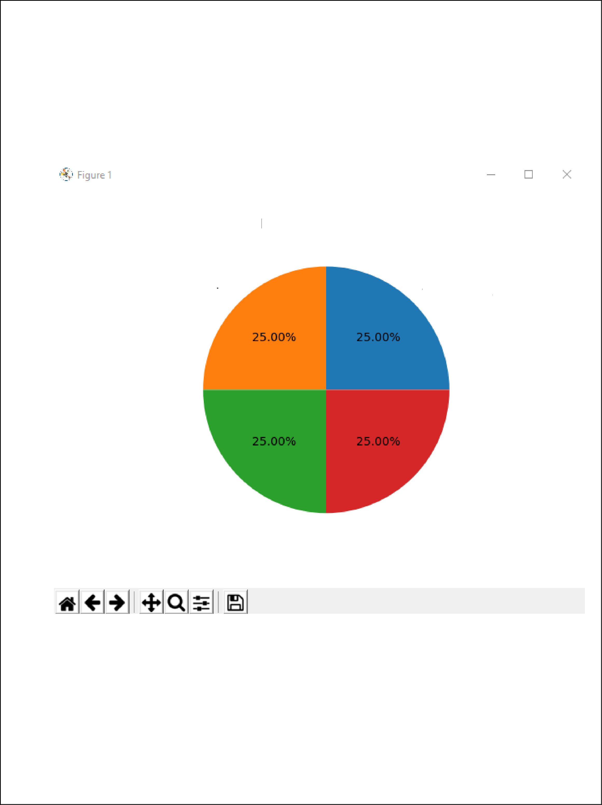

No. of Transactions

Withd ravvals

Fund Transfers PIN Change

#### <> Select the Serial Number of the Service you want or Hit 6 to EXIT:5

**Select Your Desired Service**

**>> 1.Transaction History 2. Account Visualisation 3.Account Activity**

**Enter Your Choice:2**

**>> 1. Activity Chart 2. Balance Monitor Enter the Choice:2**

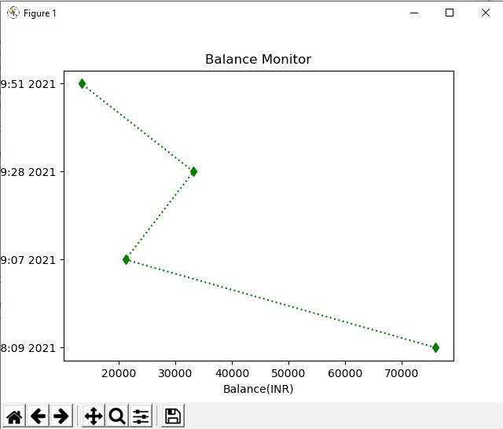

**<> Select the Serial Number of the Service you want or Hit 6 to EXIT:5**

**Select Your Desired Service**

**>> 1.Transaction History 2. Account Visualisation 3.Account Activity**

**Enter Your Choice:3**

**{'Activity': 'PIN Changed', 'Date_And_Time': 'Tue Jan 1219:00:222021'}**

**<> Select the Serial Number of the Service you want or Hit 6 to EXIT:6**

**>>> Thank You For Using The ATM <<<**

**>>>**

CONCLUSION

This program is an operative and efficient prototype of an Automated Teller Machine. The program interface is simple and suits any type of user. The program is a multi-utility device which makes it versatile. It comes with every type of service that you need in daily life like cash withdrawal, money transfer and account visualisation.

The prototype is programmed with python because of its resourcefulness and flexibility. The program syntax is simple and even a novel user can comprehend the program without difficulty. In addition, the program offers simple formatting options and new options can be added easily.

**BIBLIOGRAPHY**

Reference TextBook: **Introduction to Python** by *Sumita Arora*

Þ[www.google.com](http://www.google.com/)

Þ[www.stackexchange.com](http://www.stackexchange.com/)

Þ[www.wikipedia.com](http://www.wikipedia.com/)

Þ[www.w3schools.com](http://www.w3schools.com/)